**5 group of B20-02**

**Maksim Filonov**

**Eduard Zaripov**

**Rostislav Zhukov**

**Nickolay Platonov**

**Dmitry Beresnev**

**Seminar Week 2**

**PHIL 1**

**Exercises**

Circle the signals and highlight the conclusions in the following passages

1. Our whole class has to stay after school for an hour. ***So*** **I’m going to need a ride home,** because the bus leaves right after school.

2. Humans and many higher animals have similar neurophysiological structures. Humans and animals exhibit many of the same behavioral responses to stimuli. It is reasonable to suppose that animals feel pain and pleasure as we humans do.

3. “And he went from there, and entered their synagogue. And behold, there was a man with a withered hand. And they asked him, ‘is it lawful to heal on the Sabbath?’ so that they might accuse him. He said to them, ‘what man of you, if he has one sheep, and it falls into a pit on the Sabbath, will not lay hold of it and lift it out? Of how much more value is a man than a sheep? So it is lawful to do good on the

Sabbath’” (Matthew 12:9–12).

4. Two out of three people interviewed preferred Zest to another soap. Therefore Zest is the best soap available.

5. In the next century, more and more people will turn to solar energy to heat their homes because the price of gas and oil will become prohibitive for most consumers and the price of installing solar panels will decline

**Completing an Argument**

Complete the following arguments, using all and only the words from the following list:

benevolence, depends, develop, effective, fails, homicide, never, unless, virtues, why

1. God has all the virtues. And **benevolence** is one of the **virtues**. So God must have benevolence.

2. Abortion involves the taking of a human life. That’s **homicide**, and you would **never**

encourage homicide, would you? So abortion should not ever be encouraged.

3. Prisons do not rehabilitate anyone. No criminal penalty that **fails** to rehabilitate can be **effective**. That’s **why** prisons are ineffective as punishment for criminal behavior.

4. The United States must become energy independent. **Unless** we develop widespread collection and use of solar energy, our survival **depends** on increasingly scarce petrochemical energy.

That’s why the United States should **develop** widespread collection and use of solar energy.

**Diagram the following passage**

There are profound mysteries in the universe, and (1) only the investigation of such a mystery is truly worthy of a lifetime of scientific investigation. Take the profoundly mysterious intelligence of Thermos bottles: clearly (2) we are here in the presence of a life-form the nature of whose cognitive capacities eludes us. (3) A Thermos keeps hot things hot and cold things cold. But how does it know? (4) It has no discernable sense organs. (5) It has no organic parts. (6) Yet the Thermos reliably differentiates its responses, (7) which is a sure sign of intelligence. I (8) therefore propose to dedicate the remainder of my scientific career to the problem of communicating with this novel life form, as (9) this is a problem worthy of such research.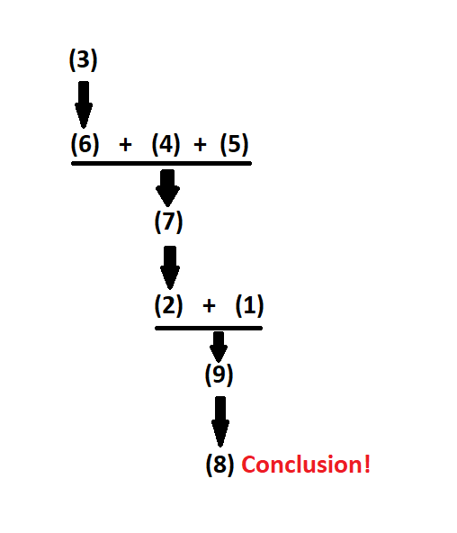

**Logical Structure**

Identify the logical structure of each of the following examples and write it down without looking at the slides from the lecture

"If it is a car, then it has wheels. It is a car. Therefore, it has wheels."

Modus ponens

A->B. A is true. Therefore, B is true.

"If it is a car, then it has wheels. It does not have wheels. Therefore, it is not a car."

Modus tollens

A->B. B is false. Therefore, A is false

"If it is a car, then it has wheels. It has wheels. Therefore, it is a car."

Affirming the Consequent

A->B. B is true. Therefore, A is true

"If it is a car, then it has wheels. It is not a car. Therefore, it does not have wheels."

Denying the Antecedent

A->B. A is false. Therefore, B is false

**Here are less sensible examples. Can you determine whether these are examples of Modus Ponens, Modus Tollens, Disjunctive Syllogism or one of the incorrect constructions (affirming the consequent, denying the antecedent)? Language is irrelevant, focus on the structure of the sentence. Again once you identified the logical structure at stake, try to write down its formula without looking at the slides.**

"If Xyrplex is 9, Guffaw is 1. Guffaw is 2. Therefore, Xyrplex is not 9."

Modus tollens

A->B. B is false. Therefore, A is false

"If Nagini is a Snake, Snape is a goner. Nagini is a snake. Therefore, Snape is a goner."

Modus ponens

A->B. A is true. Therefore, B is true.

‘Either the Sun orbits the Earth, or the Earth orbits the Sun. The Sun does not orbit the Earth. Therefore, the Earth orbits the Sun.

Valid disjunctive syllogism

A or B. Not B. Therefore, A.

"If Blurts are Flurts, Green is Grue. Green is Grue. Therefore, Blurts are Flurts."

Affirming the Consequent

A->B. B is true. Therefore, A is true

"If Sagan has hair, Tyson is awesome. Sagan has hair. Therefore, Tyson is awesome."

Modus ponens

A->B. A is true. Therefore, B is true.

"If Fordham brings a ram, Peruna will kick. Fordham did not bring a ram. Therefore, Peruna did not kick’’

Denying the Antecedent

A->B. A is false. Therefore, B is false

‘The cake has either chocolate or vanilla frosting. The cake does not have vanilla frosting. Therefore, the cake has chocolate frosting’.

Valid disjunctive syllogism

A or B. Not B. Therefore, A.